Digestion of pasta

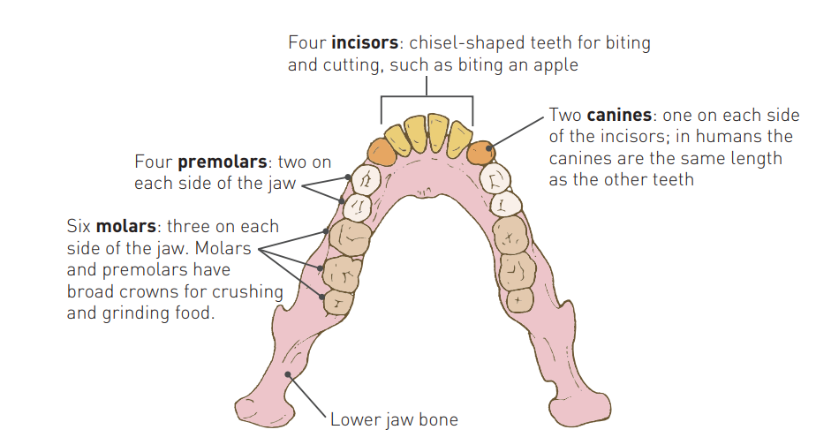
Mouth and oesophagus:
Figure 1- structure of mouth (teeth positioning) Newton, T. J., & Joyce, A. (2014). Human Perspectives Units 1 & 2: For the ATAR Course.
once intake of pasta has occurred at the mouth, due to the process of the jaw moving up and down and the teeth breaking up the pasta, mechanical digestion begins. The Pasta is broken up into smaller pieces. The teeth of the jaw consist of four incisors for bring or cutting, two canine used for tearing, four premolars, and six molars for crushing and grinding as seen in figure one. As the pasta is being chewed it mixes with saliva, a fluid that is released from the salivary glands in the oral cavity. This fluid contains mucus and salivary amylase, which begins chemical digestion. Amylase in the saliva begins to break down the complex carbohydrates that pasta is into a sugar molecule called maltose immediately as the mechanical digestion process begins. After the pasta has been broken down into smaller pieces and mixed with saliva, the tongue forms the pasta into a rounded lump called bolus. Once the bolus if formed, the pasta is then ready to be swallowed. When a person swallows the epiglottis folds backwards in order to cover the entrance of the larynx to stop food and liquid from entering the windpipe and lungs. Directly after swallowing the epiglottis returns to its normal position. Once the pasta bolus has passed the epiglottis and entered the pharynx then into the oesophagus where the circular muscle that make up the wall of the oesophagus contracts to form a constriction. This constriction moved in a wave along the oesophagus, pushing the food in front of it. This is called peristalsis. This is aided by secretion of mucus from the inner lining of the oesophagus as a lubricant.
Stomach:
once the bolus of pasta(carbohydrate) has entered the stomach it is again mechanically digested by waves of muscular contraction that moves along the stomach wall. These muscles push food from the upper part of the stomach to the lower part of the stomach, where the chemical digestion begins. The contractions forcing the bolus of pasta from the upper part of the stomach to the lower causes the pasta bolus to mix with the gastric juices that convert the bolus into a thick soupy material called chyme. Chemical digestion occurs typically in the stomach by specific enzymes that are released from the stomach (hydrochloric acid, mucus and digestive enzymes(pepsin)) that work to breakdown the material, but complex carbohydrates are not apart of this category as they are broken down chemically in the duodenum. Due to the inactivation of the salivary amylase because of the acidic environment. After the bolus has been formed into chyme it moves through the pyloric sphincter, to move from the stomach into the duodenum.
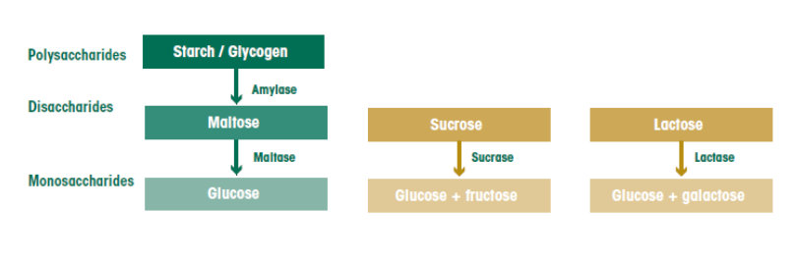
Small intestine (break down):
Figure 2
after the stomach, the chyme enters the duodenum where it will mix with secretion from the pancreas (pancreatic amylase, pancreatic lipase, trypsin, and ribonucleases & deoxyribonuclease) and the duodenum (intestinal juices), and bile from the liver that is stored in the gall bladder. Pancreatic amylase starts the breakdown of dextrin’s into shorter and eventually even shorter carbohydrate chains. The amylase then continues to break down these short chains or carbohydrates into disaccharides (maltose, sucrose, lactose) and then into even smaller single units called monosaccharides (glucose, glucose+ fructose, Glucose + galactose).

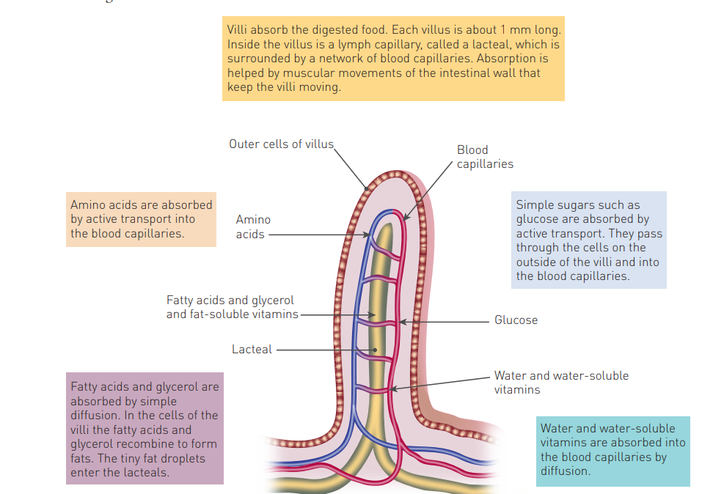
Small intestine (absorption):
Figure 2- structure of villi Newton, T. J., & Joyce, A. (2014). Human Perspectives Units 1 & 2: For the ATAR Course.
the inner mucosa layer if folded and contains villi and microvilli (tiny projections from villi ‘s external surface). Each villus about 1mm long and is covered in a thin layer of cells. Inside is a lymph capillary called a lacteal which if further surrounded by a network of capillaries. Absorption is enhanced by the continual movement of the villi due to the muscular movements of the intestinal wall which brings the villi into constant contact with the material. Some absorption occurs through Simple diffusion (high nutrient concentration in the small intestine than cells lining villi). Active transport can also occur. From the walls of the villi-simple sugars, amino acids, water and water-soluble vitamins are absorbed into the blood capillaries. These are then carried to the live via the hepatic portal vein, which may then be removed for further processing or to remain in the blood for cells.
Large intestine:
the large intestine’s role is to absorb water and electrolytes as the muscle system moves the left over waste after absorption in the small intestine along further down closer to the end of the digestive system. It does this by the process of osmosis (movement of water molecules from a solution with a high concentration molecule to a solution with a lower concentration of water molecules, through the cells partially permeable membrane). Bacteria that live in the large intestine breaks down the remaining organic compound. Some of these bacteria can produce vitamins, which are then absorbed into the bloodstream, along with mineral nutrients. These vitamins and minerals are absorbed by diffusion occurring in accordance with the osmotic gradient.

Elimination and faeces:
the dehydration along with the peristaltic waves works to compact the chyme creating a solid waste form called faeces. The faeces continue to move through the descending and sigmoid colon. The large intestine store the faeces temporarily, prior to elimination. The body expels these waste products through the rectum and anus. Defecation involves contractions and relaxation of rectal muscles and the internal anal sphincter. This reflex is mostly involuntary and under command of the autonomic nervous system. But along with this the somatic nervous system can also play a role in controlling the timing of said elimination. Normally faeces contain 75 percent water and 25 percent solid waste. 30% of said solid wastes consists of dead bacteria, another 30% Is indigestible food matter and 10-20 percent made up of cholesterol and other fats, 10-20% is made up of inorganic substances and 2-3 % is made up from protein.

Carbohydrate Digestion and Absorption - The Canadian Sugar Institute. (n.d.). https://sugar.ca/sugars-health/carbohydrate-digestion-and-absorption#:~:text=Digestion%20of%20Carbohydrates,-Before%20the%20body&text=During%20digestion%2C%20starches%20and%20sugars,as%20energy%20throughout%20the%20body.

The Editors of Encyclopaedia Britannica. (2023, April 26). Feces | biology. Encyclopedia Britannica. https://www.britannica.com/science/feces

Body, V. (n.d.). Absorption and Elimination | Digestive Anatomy. https://www.visiblebody.com/learn/digestive/digestive-absorption-and-elimination

News-Medical.net. (2022, December 2). What Does the Large Intestine Do? https://www.news-medical.net/health/What-Does-the-Large-Intestine-Do.aspx#:~:text=Function%20of%20the%20large%20intestine,formation%20and%20elimination%20of%20feces.

Newton, T. J., & Joyce, A. (2014). Human Perspectives Units 1 & 2: For the ATAR Course.

